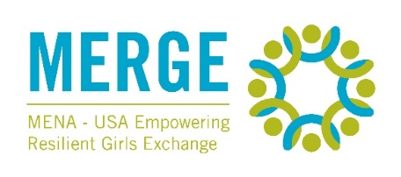
MENA – USA Empowering Resilient Girls Exchange (MERGE) Facilitator Application Questions Draft

The MERGE facilitator application contains four (4) open response questions, and two (2) file uploads. You are unable to save the application once you start. We recommend you draft your answers below before completing the application.

Open Response Questions
- Why are you interested in being a facilitator for a program focused on youth mental health and resilience? What personal and/or professional experience do you have with this subject matter?

- Please share an example of a time you coached or mentored someone from a background different from your own. What challenges did you face? How did you overcome them? What improvements did you see in the person's knowledge or skills at the end of this experience?

- MERGE is a completely virtual program and much of the work conducted by facilitators and participants will be asynchronous (content will be available online for participants to access when it best suits their schedules). Describe an experience that demonstrates your ability to manage time effectively. What were the challenges and results?

- In your opinion, what can facilitators do to promote intelligent but respectful dialogue in an online space?

File Upload Prompts
- Please upload an (up to) 90 second audio or video response to the following questions: Why are you interested in serving as a MERGE facilitator? What unique skills and experiences would you bring to the program?

- Please upload a current resume that specifically reflects any experience you have mentoring young women, working on mental health awareness or support projects, and/or facilitating or planning online events.

